PREFERRED LODGING HELD UNTIL

August 11, 2019

Mr./Mrs./Ms.______________________________________

Street___________________________________________

City _______________________________ St ___ Zip_____

Day Phone (______)___________
Eve Phone (_____)____________

Arrival Date:___/___ Departure Date___/___ #Nights_____

Special Requests: (i.e. Room accessibility, dietary, etc.)
Explain:__________________________________________

METHOD OF PAYMENT

___ Check-Must be sent with form
___ Purchase Order – Must be sent with form
___ Credit Card

VISA MC DISCOVER AMEX

Card # _____________________________________ Exp._____/_____

Cardholder’s Name: _________________________________________

Signature: _________________________________________________

CANCELLATION POLICY
Individual reservations cancelled within 72 hours of the schedule arrival will be charged the entire package price on the date of the cancellation. If payment is made by check, we will refund you’re the entire amount if the cancellation is made prior to 72 hours of your expected arrival. We will keep the entire amount paid by check if cancelled within 72 hours of your arrival.

GROUP PACKAGE (Please select one)

___ $182.93 Single Occupancy/Per Person

___ $128.27 Double Occupancy/Per Person

The Package Includes the following: Overnight Accommodations for Thursday Night, Afternoon Break and Dinner on Thursday, Continental Breakfast and Beverage break on Friday, Tax and Gratuity.

ROOMMATES

If you choose double occupancy, you must list your roommate below and mail or fax your forms together otherwise your reservation will be changed to the single occupancy rate.

List name of the roommate you’ve selected:

________________________________________________

** All of our Guestrooms are Non-Smoking

MAIL OR FAX ENTIRE FORM TO:
Arrowwood Resort & Conference Center
2100 Arrowwood Lane NW
Alexandria, MN 56308
FAX: 320-762-0133

NO RESERVATIONS ACCEPTED WITHOUT FORM

CHECK-IN TIME IS 4 P.M./CHECK-OUT IS 11:00 AM.

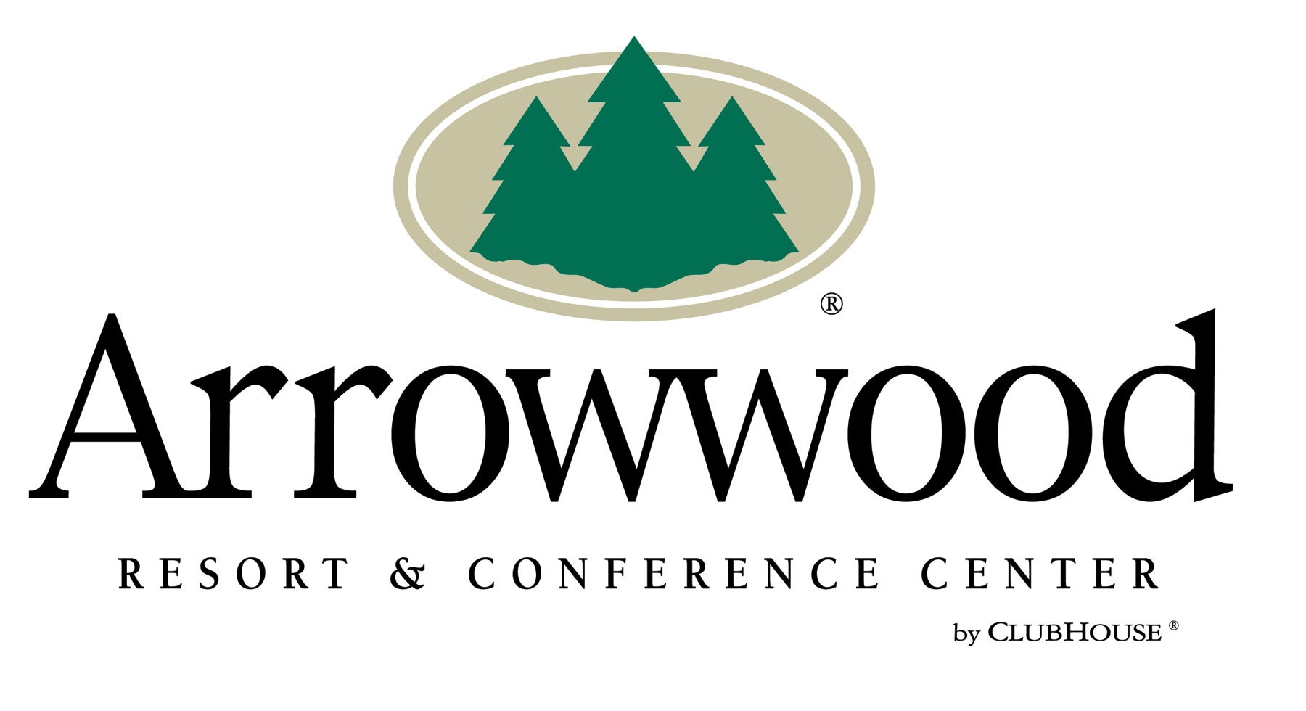

MN State Association of Narcotics Investigators

September 10-11, 2019 Fall Conference

Arrowwood Resort & Conference Center Lodging Form

